Skill Week 10
Aim
To learn how to handle Linux signals by registering a signal handler, responding to an interrupt such as SIGINT, and verifying the signal-handling behavior using a simple C program.
Program:
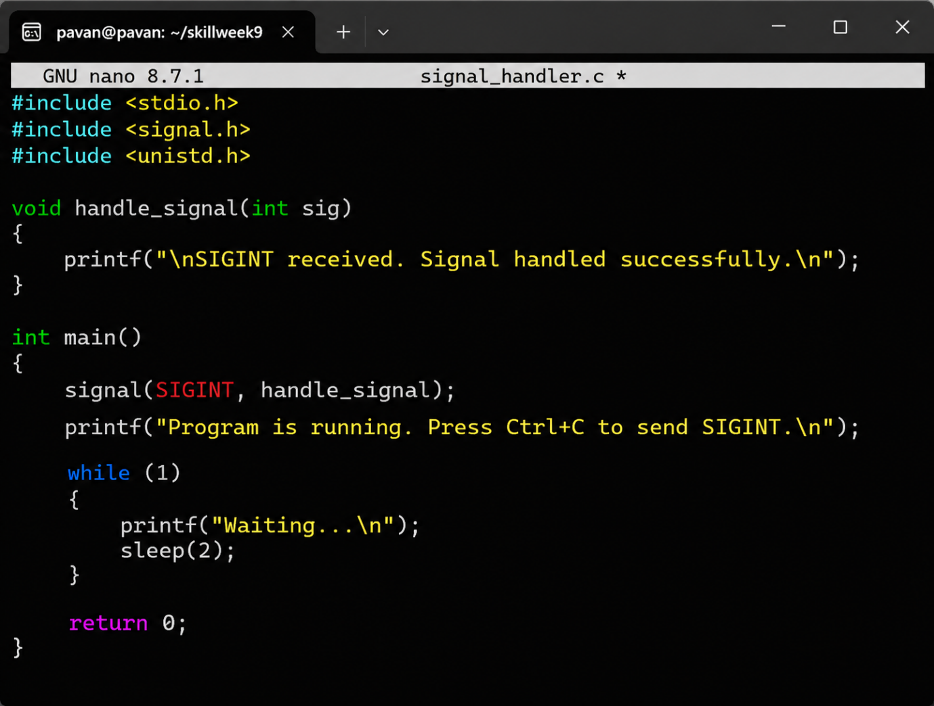

Output
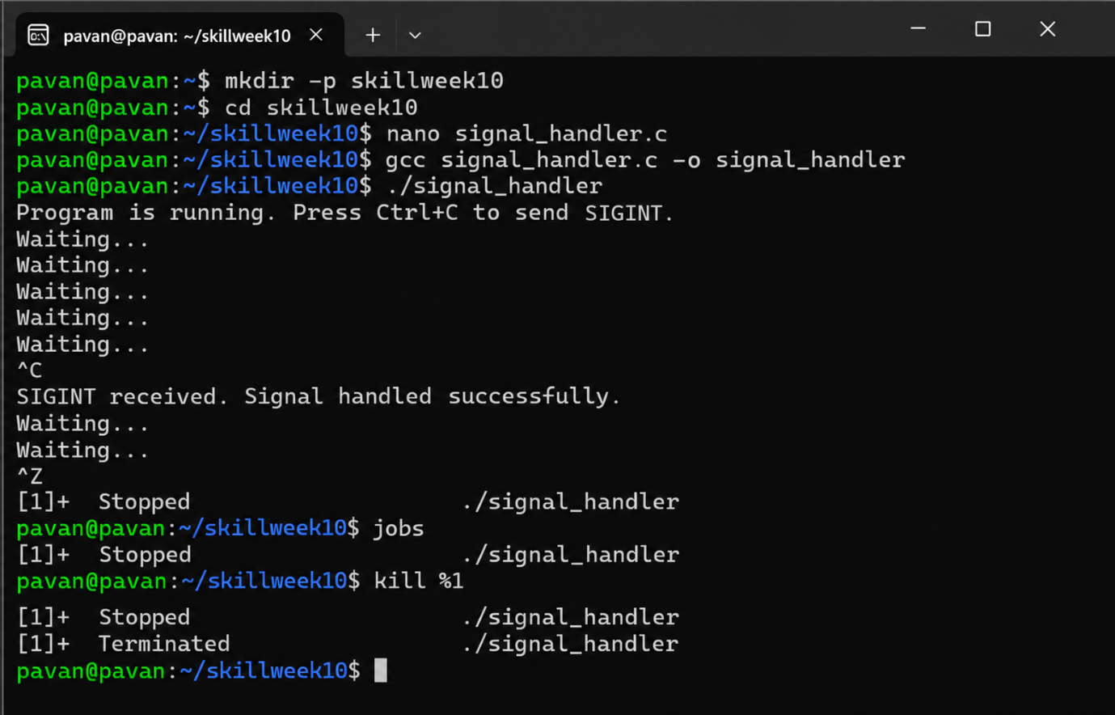
Observation
The signal() function registered a handler for SIGINT. When Ctrl+C was pressed, the signal handler executed and displayed a message instead of allowing the default termination behavior.
Result
A Linux signal handler was successfully registered, tested, and verified using a C program and SIGINT.

Aim
To understand how SIGINT is generated by Ctrl+C, how signals affect foreground processes, and how a process can handle SIGINT without immediately terminating.
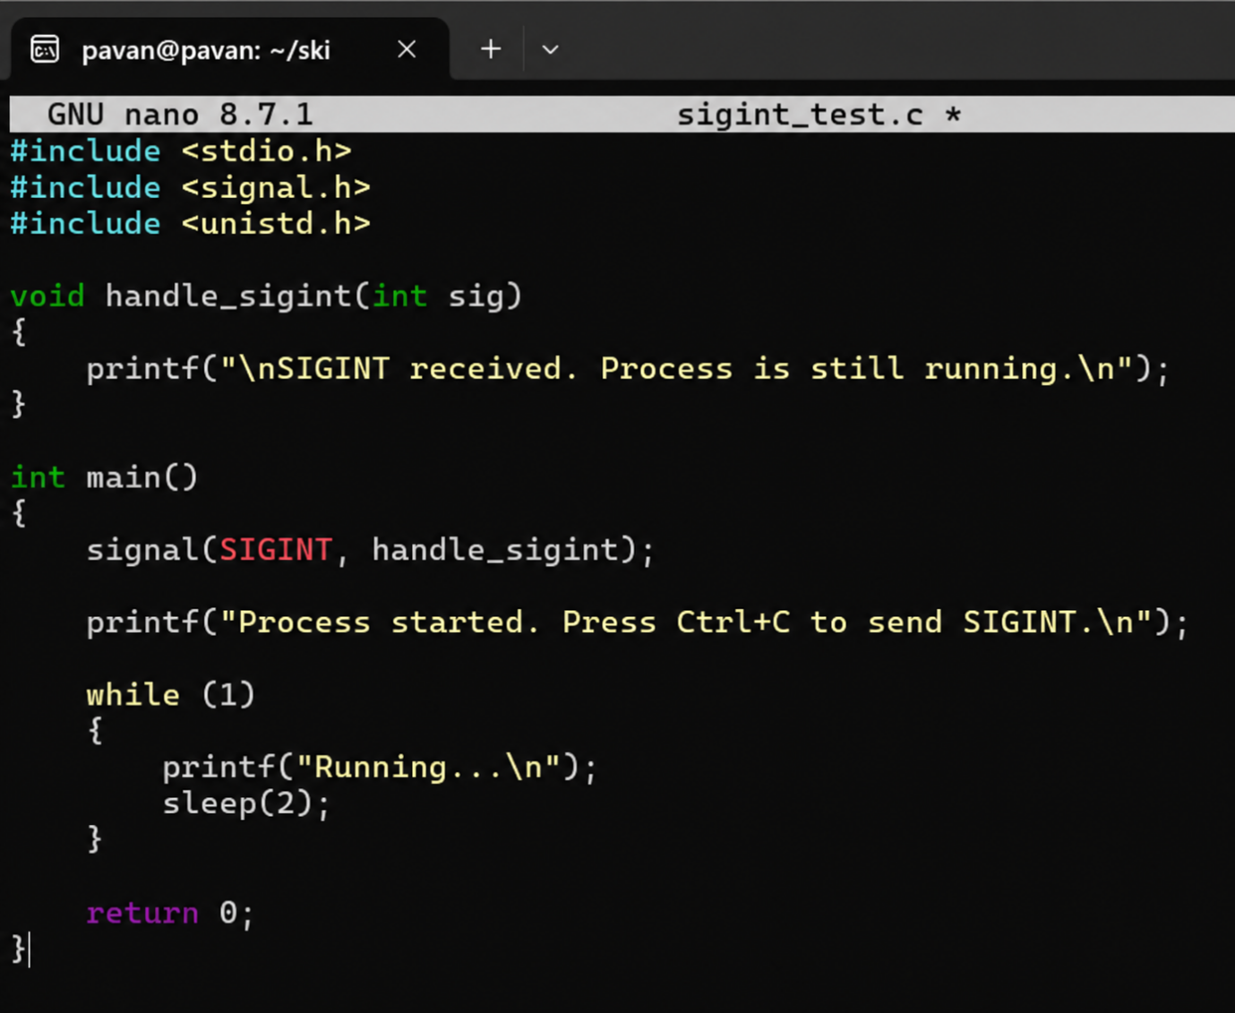
Output:
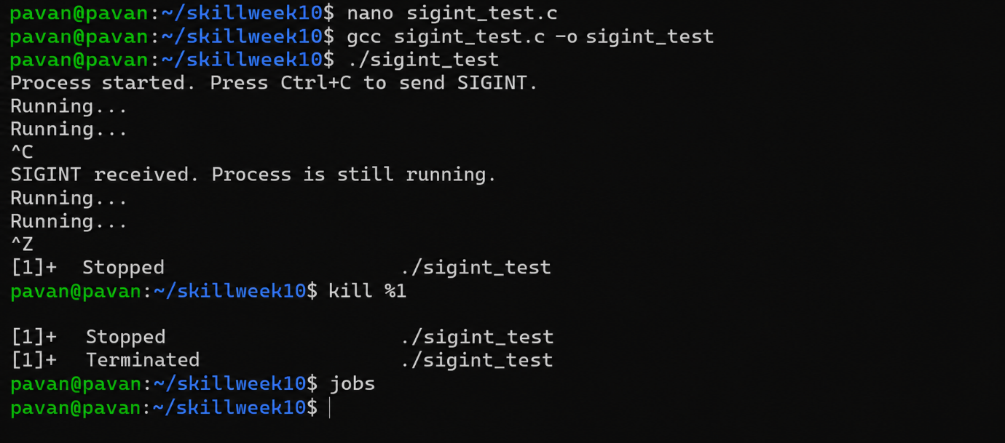

Observation
Ctrl+C sends SIGINT to the foreground process. The registered signal handler catches the signal and allows the program to continue. Ctrl+Z stops the foreground process and places it in the job table.
Result
SIGINT handling, foreground-process interruption, job-state updating, and process termination were successfully tested.

Aim
To understand how SIGTSTP suspends a foreground process, how the suspended process appears in the job table, and how to resume the process later.
Program:
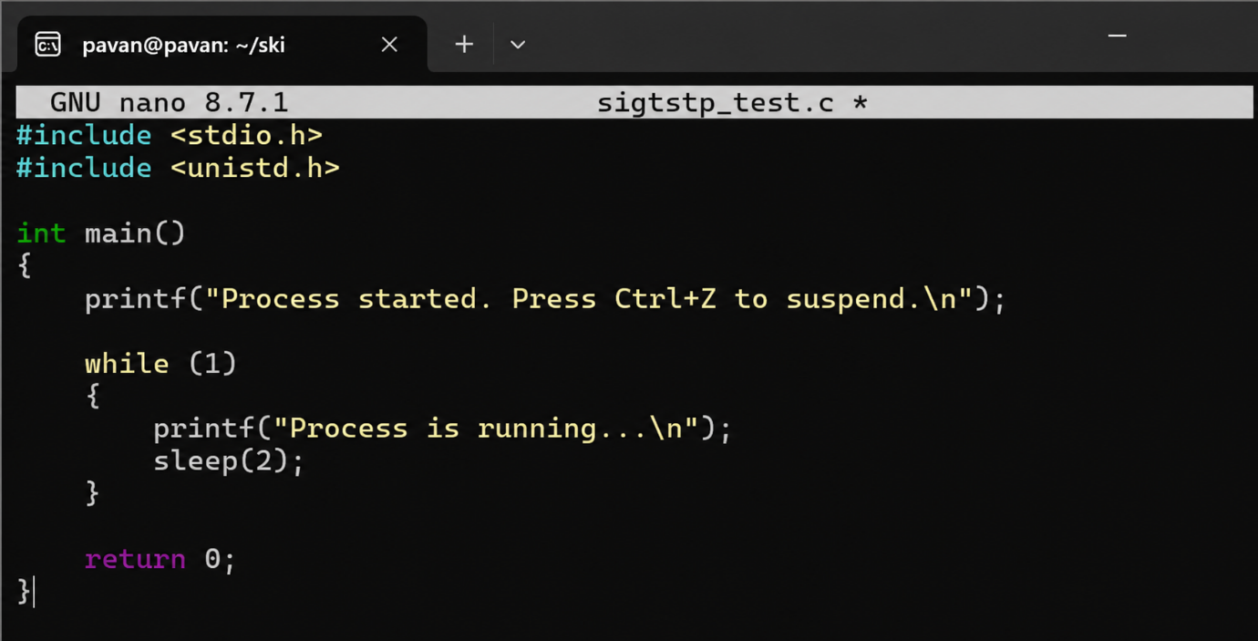

Output:
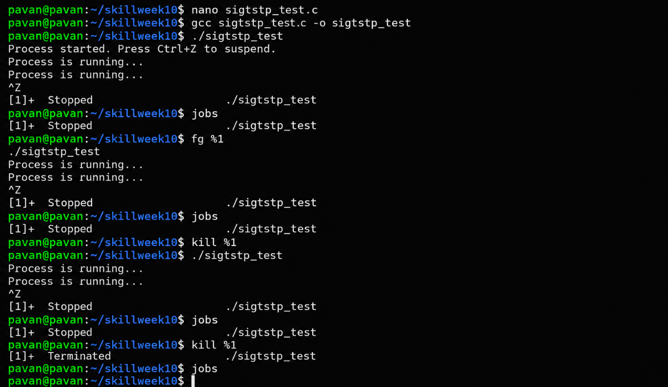
Observation
Ctrl+Z sends SIGTSTP to the foreground process and suspends it. The jobs command shows the process as Stopped. The fg command resumes it in the foreground, while bg resumes it in the background.
Result
The SIGTSTP suspension and process-resume workflow was successfully implemented and verified using Linux job-control commands.

Aim
To understand process groups and terminal control in Linux by creating a background process, checking its process group, transferring it to the foreground, and observing its execution.
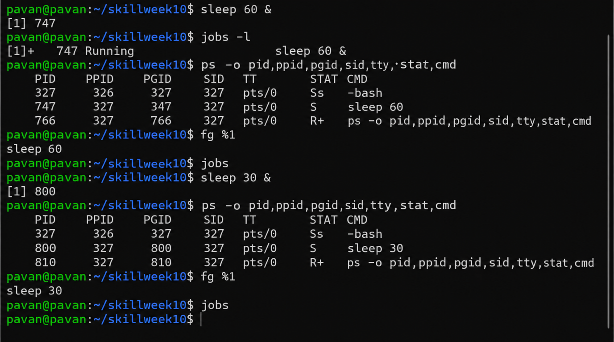
Observation
The ps command displays the process ID, parent process ID, process group ID, session ID, terminal, and process state. The fg command transfers a background job to the foreground and gives it terminal control.
Result
Process groups and terminal ownership/control were successfully observed and verified using Linux process and job-control commands.

